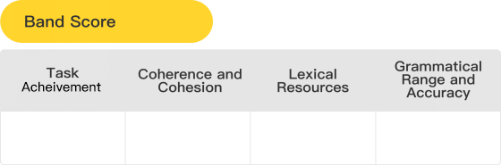

**6.0**

**6**

**6**

**6**

**6**





Karren

1/2/2023

作文标题图片

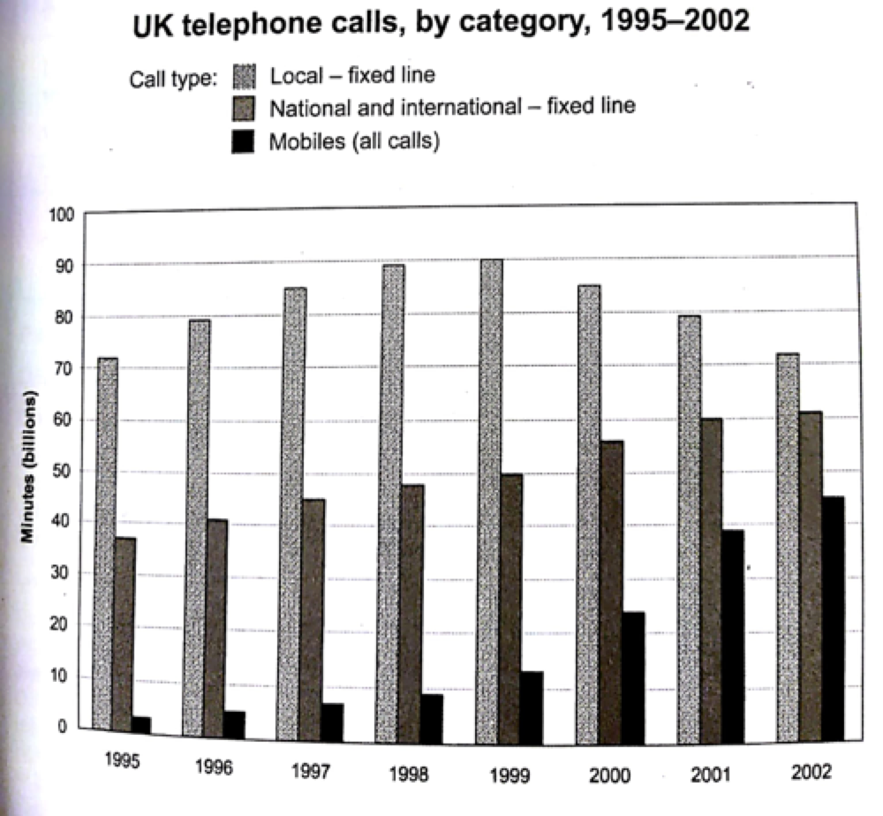



|  |  |
| --- | --- |
| Type of chart/graph | Dynamic Bar Graph |
| Language Needed | Highest, lowest, increase, decrease |
| Unit or Label | Minutes |
| Suggested Grouping | 1st body paragraph: details for 1995  2nd body paragraph: details throughout the rest of the period |



The given **bar** chart ~~below~~ ~~shows~~ **illustrates** the ~~cumulative minutes (in billions) of the telephone calls into~~ the **amount of time that people spent on** three types **of phone calls** in the UK between 1995 and 2002.

|  |
| --- |
| **NOTE: It is better to state the type of chart here to indicate that you have knowledge on the different types of chart.** |

Overall, **the amount of time spent on** local ~~call type~~**-fixed line** was the ~~most popular call type~~ **highest** in ~~the~~ **this** period, which ~~is~~ **was** followed by national and international call and mobies call ~~and situated at second and third respectively~~, and ~~posed~~ **had a** rising tendency throughout the ~~span~~ **period**, ~~but vary by increasing speed~~ **except for the figure for the former, wherein it dropped in 2002**.

|  |
| --- |
| **NOTE: The presentation of the overview was okay, but it should present the general features of the chart including the trend and ranking. Here’s a better overview presenting the general trend and ranking:**  **SAMPLE OVERVIEW:**  **Overall, the figure for local-fixed line increased before 1999, but then it decreased in 2002, while that for national and international-fixed line and mobiles had a growing trend throughout the period. It is notable that the amount of time spent on local-fixed line was the highest among the three different phone calls, while mobiles calls still had the least.** |

~~First~~ **In more details**, ~~put the eyes on~~ **the figure for** local ~~call~~**-fixed line**~~, started from~~ **was about** 72% in 1995**, and** then climbed gradually ~~until~~ **in** 1999, ~~when~~ **and** reached ~~the~~ **its** peak ~~-~~ **of** 90%. After that, **it** declined ~~with more rapid compare with how it rose before. Finally, reached~~ back to the ~~original degree –~~ **amount of that of in the beginning, at** 72%.

|  |
| --- |
| **NOTE: The details for local-fixed line were presented here, but some terms were incorrectly used. Here’s a better body paragraph presenting the details:**  **SAMPLE BODY PARAGRAPH:**  **To be more specific, in 1995, the figure for local-fixed line was the highest with over 70 billion minutes. Furthermore, the amount of time consumed on national and international fixed-line was about 39 billion minutes, while that of mobiles was the lowest, at nearly 5 billion minutes.** |

~~The others,~~ **As for the figures for** national and international ~~call~~ **fixed line** and mobi**l**es call~~.~~**,** ~~T~~**t**he ~~first one began~~ **former rose** from approximately 37% in 1995 ~~with a moderately rose~~ to ~~approximately~~ **around** 61% in 2002. However, the latter one ~~bursted with~~ **had** a dramatic soar after 1998, from about 9% to 45% in 4 years, ~~while~~ **wherein** it ~~climbed~~ **rocketed** ~~slowly before -only about a~~ **from nearly** 3% ~~amounts of increase in 3 years~~ **in 1995**.

|  |
| --- |
| **NOTE: The details for the other two categories line were presented here, but some terms were repetitive and the idea was not presented properly. Here’s a better body paragraph presenting the details:**  **SAMPLE BODY PARAGRAPH:**  **Furthermore, the figure for local-fixed line rose and reached its peak of around 90 billion minutes in 1999, before it dropped back to the same as that of in the beginning. As for the national and international fixed-line and mobiles, the amount of time used grew to almost 60 billion minutes and approximately 40 billion minutes, respectively in 2002.** |

Hi Dear,

The changes made are suggestions on how to make the essay better and avoid repetitive terms, unless specified in the comment as incorrect data or presentation. There are comments for each revision, explaining why a phrase/word/sentence was changed. The goal is to make the essay score at least 6.5-7.0. Description: Description: Description: Description: 🙂

|  |
| --- |
| **Word count: 173** |
| **Task Achievement**  *the examiner is looking for 3 things:*   * ***Overview*** *(Mention two of the most noticeable or important trend)* * ***Grouping*** *(group the data into two and compare them in separate paragraphs)* * ***Write enough words*** *(should be* ***at least*** *150 for task 1 and 250 for task 2, should not be* ***wordy****)* | **Assessment and Comments** |
| The details were presented with some inaccuracies  Overview did not clearly present the general ranking and trend |
| **Suggestion and Improvement** |
| **types of charts**    **How to Write The Overview (Line graph, pie chart, bar graph, table - dynamic)**   1. An overview is one of the first things an examiner looks for because it shows them that you can identify the most important information from the graph or chart and clearly identify overall trends and comparisons. 2. In the overview state what the main trend or trends in the graph are. Don’t give detail such as data here – you are just looking for something that describes what is happening overall. 3. You should not only highlight the general trends (increase/decrease) but also compare the main features (highest/lowest). Leave the bullet points in the body part. Look at the "big picture" - what changes happened to all of the patterns/lines/sections from the beginning to the end of the period shown (i.e. from the first year to the last). Is there a trend that all of the lines follow (e.g. an overall increase)? 4. If there are no general trends such as overall increases, then just use the main features (highest/lowest) for the overview. 5. If NOT all increased/decreased/ not dominant in all years, make use of *most, almost all, the majority, a large amount, a large proportion, nearly all*   ****When we are looking at dynamic graphs we should be looking out for:   * What does the data do from the start to the finish? * Do they generally go up or down or do they fluctuate? * Any significant difference from the general trend? * Overall increase/decrease? Peaks/lows?   **BODY PARAGRAPH FOR DYNAMIC CHARTS**   1. If the graph shows many figures or there are many charts, you won't have time to mention all of them. The key features to describe are the highest, lowest, and similar figures; and the key years are first and last year; You should also mention any 'special' years (e.g. a peak or a significant rise/fall or crossing lines). 2. the first and last figures or years are important to clearly explain the progression of data. (this is very important for continuous rise or fall.)   In Task 1, you should group the data well. ***to make a logical division of data, group the bullet points and place them in each body according to their rank/trend and make relevant comparisons. |
| **Coherence and Cohesion**  *the examiner is looking for* ***4*** *things:*   * ***Paragraphing*** *(has a clear topic sentence or main idea which should be the first sentence; with enough details and examples)* * ***Logical organization of the essay*** *(main ideas should be progressing. Each paragraph is linked to the others especially to the central idea or position in the introduction)* * ***Cohesive devices need to be used well*** *(sentences should be linked smoothly to each other with the use of proper cohesive devices and transitional devices.)* * ***Referencing*** *(there should be usage of referencing like pronouns and substitutes.)* | **Assessment and Comments** |
| Flow of ideas is not clear throughout due to inaccurate details  Cohesive devices were used with some inaccuracies |
| **Suggestion** |
| Why do students have issues with Cohesion and Coherence?  1. **Sentence construction:**Many students have **issues creating good sentences** in English. **Writing is still a very specific skill and even more so is Academic writing**. They either write **too short sentences** or have **too long sentences** with too many clauses. Sometimes they have clauses which should be in a different sentence. Other times they think that a paragraph is just one long sentence filled with commas. **Sentence construction is crucial for a good IELTS score**, sadly enough it is not covered in almost any IELTS course, as one expects you to have the basics. 2. **Sentence connection:** Some of the issues mentioned before, are the same here. Since one does not know how to construct sentences, one does not know **how to connect** them. Other issues are **not connecting sentences logically**. You are writing an **Academic essay, which means you defend your positions, arguments and choices you make.** If you say people hate smartphones you need to be able to tell me why. This also needs to be done in a convincing way. Just saying because, is not enough. **Connecting your sentences logically helps you defend your position and arguments.** 3. **Paragraph construction:** Students have issues with paragraphs because **some students just don’t use them**, they write one big text. This is not how Academic writing works, you need to have **clearly marked paragraphs**. Other issues are due to **lack of planning**, students **add some things at the end** which they forgot to write about. This is then not in the correct paragraph, which means you don’t have one central idea. This is the next issue, **people put too many ideas in one paragraph**, which should be put in different paragraphs. All these things lead to issues with progression. 4. **Essay construction:**Due to **lack of planning** mostly, people **add things here and there** at the time of their writing. Oh I still need to say this, and I forgot to mention this. As a result, their **essay is badly constructed, not logical and impossible for the reader to understand**. All this leads to a break down in cohesion and coherence. There is **no clear beginning middle and ending**, leading to issues with progression. 5. **Punctuation:**The biggest issues here are either **not using any punctuation**, or the **overuse of commas**. 6. **Linking words:** The same issue as with punctuation. Either students **use too many** of them or most of the time, **not enough** of them. Another issue is that students are **not using the correct linkers for academic writing**. They use connectors such as ‘and’, ‘but’, ‘because’,… to start sentences, which is ok when you speak, but in academic writing these are used to connect clauses within a sentence. Therefore**it is crucial to be familiar with linkers and how they are used**. 7. **One clearly expressed idea per paragraph:**This is done by **writing a good topic sentence.**The topic sentence **explains briefly and to the point what the paragraphs is about**. Many students **do not write a topic sentence** for their body paragraphs or **do not know how to properly construct a topic sentence.** 8. **Referencing:**Students don’t always use referencing correctly, or have issues with it. They **use the same references all the time**, or **do not use enough synonyms**. Other times for example they **forget this little ‘it’**in sentences. **Using correct referencing makes it easier for the reader to understand what you’re saying.** |
| **Lexical Resource**  *the examiner is looking for* ***4*** *things:*   * ***Range of vocabulary*** *(uses less common words precisely, minimal repeated words, not wordy)* * ***Spelling*** *(frequency of error)* * ***Collocation*** *(word combination makes sense, not just one correct word but a group of correctly related words)* * ***Word families*** *(words are in the correct form, correct parts of speech)* | **Assessment and Comments** |
| uses an adequate range of vocabulary for the task  attempts to use less common vocabulary but with some inaccuracy  makes some errors in spelling and/or word formation, but they do not impede communication |
| **Suggestion** |
| **Trends**   1. Increase - incline, climb, rise, soar, etc. 2. Decrease - decline, drop, fall, slump, etc. 3. Levelled out - did not change, remained stable, remained steady, stayed constant, etc. 4. Fluctuation - Use when there were three changes in the trend 5. Highest point - peak, summit, crest 6. Bottom out - through, lowest point   Describing Trends   1. Verbs to express ‘up’ and ‘down’  * **Upwards:** Increase; Go up; Rise; Grow; Jump * **Downwards:** Decrease, Go down, Fall, Decline, Drop, Plunge, Plummet, slump   B. Nouns to express ‘up’  - **VERB**: Increase, Rise, Grow, Jump  - **NOUN:** An increase, A rise, A growth, A jump  C. Nouns to express ‘down’  - **VERB:** Decrease, Fall, Decline, Drop, slump  - **NOUN:** A decrease, A fall, A decline, A drop, A slump  D. Adverbs and adjective to express ‘small’ or ‘slow’ changes  - **Adjectives**: Slow, Gradual, Marginal, Slight, Insignificant, Minimal, Minor  - **Adverbs**: Slowly, Gradually, Marginally, Slightly, Insignificantly, Minimally  E. Adverbs and adjectives to express ‘large’ or ‘fast’ changes  **- Adjectives:** Sharp, Steep, Rapid, Dramatic, Sudden, Significant, Considerable, Marked, Major, Wild, erratic  **- Adverbs:** Sharply, Steeply, Rapidly, Dramatically, Suddenly, Significantly, Considerably, Markedly, Wildly, erratically  F. Adjectives and adverbs for other changes  - **Adjectives:** Steady, continuous, General, Occasional, Final, initial  - **Adverbs:** Steadily, Continuously, Generally, Occasionally, Finally, initially |
| **Grammatical Range and Accuracy**  *the examiner is looking for 2**things:*   * ***Accuracy of grammar*** *(how many sentences are error free, what kinds of mistakes were committed, accuracy of simple and complex grammar. Were the errors slips or did they create confusion on the intended meanings )* * ***Range of grammar*** *(uses more complex structures, sentences are clearly organized)* | **Assessment and Comments** |
| uses a mix of simple and complex sentence forms  makes some errors in grammar and punctuation but they rarely reduce communication |
| **Suggestion** |
| Definite Article: the The definite article is used before singular and plural nouns when the noun is specific or particular. The signals that the noun is definite, that it refers to a particular member of a group. For example:  "The dog that bit me ran away." Here, we're talking about a *specific* dog, the dog that bit me.  "I was happy to see the policeman who saved my cat!" Here, we're talking about a *particular* policeman. Even if we don't know the policeman's name, it's still a particular policeman because it is the one who saved the cat.  "I saw the elephant at the zoo." Here, we're talking about a *specific* noun. Probably there is only one elephant at the zoo. Count and Noncount Nouns The can be used with noncount nouns, or the article can be omitted entirely.   * "I love to sail over the water" (some specific body of water) or "I love to sail over water" (any water). * "He spilled the milk all over the floor" (some specific milk, perhaps the milk you bought earlier that day) or "He spilled milk all over the floor" (any milk).   "A/an" can be used only with count nouns.   * "I need a bottle of water." * "I need a new glass of milk."   Most of the time, you can't say, "She wants a water," unless you're implying, say, a bottle of water. Geographical use of the There are some specific rules for using the with geographical nouns.  Do not use the before:   * names of most countries/territories: *Italy, Mexico, Bolivia*; however, *the* Netherlands, *the* Dominican Republic, *the* Philippines, *the* United States * names of cities, towns, or states: *Seoul, Manitoba, Miami* * names of streets: *Washington Blvd., Main St.* * names of lakes and bays: *Lake Titicaca, Lake Erie* except with a group of lakes like *the Great Lakes* * names of mountains: *Mount Everest, Mount Fuji* except with ranges of mountains like the*Andes* or the*Rockies* or unusual names like the*Matterhorn* * names of continents (Asia, Europe) * names of islands (Easter Island, Maui, Key West) except with island chains like the Aleutians, the Hebrides, or the Canary Islands   Do use the before:   * names of rivers, oceans and seas: the*Nile,*the*Pacific* * points on the globe: the*Equator,*the*North Pole* * geographical areas: the*Middle East,*the*West*   deserts, forests, gulfs, and peninsulas: the*Sahara,*the*Persian Gulf,*the*Black Forest,*the*Iberian Peninsula* |

感谢使用趴趴写作批改服务，如果宝宝觉得满意的话可以到淘宝给老师一个好评哦~你的好评是对老师和趴趴最好的鼓励。好评后可戳淘宝鸭鸭们领取学习大礼包。如果作文有问题的话，也可以及时联系我们沟通！祝宝宝早日屠鸭成功哦！